THE SLOT SYSTEM

- Each day has 3 slots: morning...afternoon...evening. Oftentimes a meal accompanies each slot.

- Start by carving out your *Sabbath, which is a recommended 3 slots.

- Next carve out a recommended 6 slots at home with your family. (3 of these 6 can also be your Sabbath slots)

- Next carve out a full slot for "balcony time." (See Mark’s 2004 Group Magazine article with that name.)

- Next plug in the regular meetings: staff, Wednesday night, worship, Sunday school, and any other regular occurrences.

- Next come all the things that are crucial to your ministry but are probably the things you like to do least. For some folks these are the recruiting calls, and/or follow-up calls. Some people really dread the lesson prep and writing time. The idea here is that we all have these routine tasks that we tend to push off...procrastinate...because we dread them. So, it is best to pick a slot(s) each week that you can dump all these undesirable things in. It's good to choose a time of day when you're at your best to tackle them. Then after this slot, plan a weekly reward of some type—perhaps lunch with a special person, or have it be the day you take off early and go home, or perhaps you take a few hours on this day to do whatever you want. Something like that.

*Added notes: Discipline is the effort it takes to create space for God to enter. Sabbath is regular disciplined attention to the spiritual life. Create space that is not occupied or preoccupied. Create the space; let it happen; God will be present. “Don’t just do something, stand there.

Sample rhythmic week

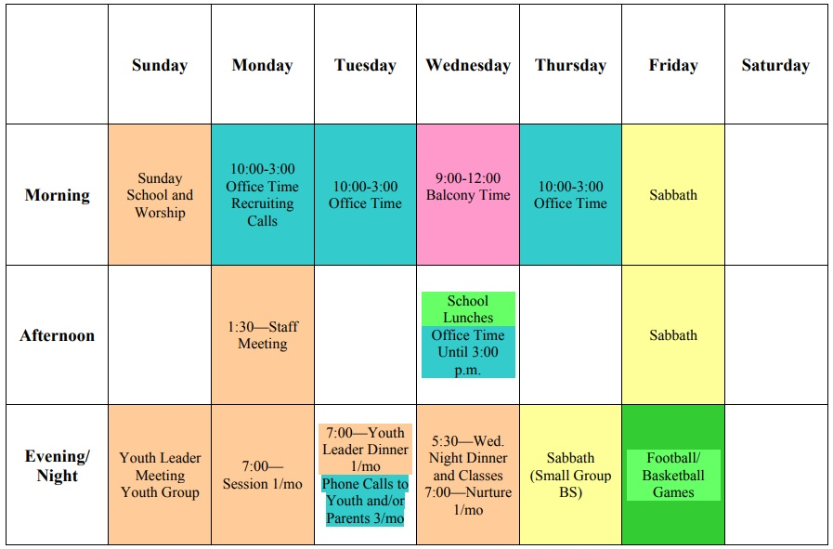

Rhythmic Week Template

