Creating a Major Event Notebook

The major event notebook is a crucial piece of the framework for any church’s children’s ministry. The first time a MENTBK (major event notebook) is created, you will be putting it together as you plan and execute the event. A MENTBK keeps you from having to reinvent each event each year. It provides a record of what has been done in the past, who did it, and for how much. And it offers a systematic checklist to make sure all the bases get covered well in advance of the event.

Setting the Stage

- Identify your major events for the year.

- Determine whether you want your event notebooks to be in electronic or printed form, or both.

- If you choose to have an electronic version (highly recommended), you’ll want to use a shared application such as Dropbox or Google Drive. With either, you can create a master MENTBK folder that contains all the templates you need and a separate subfolder for each event.

- Each time you begin a new event, copy the blank template and in the place of “Blank” put the name of the event.

- If you choose to use a physical notebook (not recommended, but some churches prefer physical copies of everything), put your notebook together in a three-ring binder. You’ll want a section with all the blank templates and a separate section in the notebook for each major event.

- Here are some suggestions for tabs to create in the MENTBK. Not all of these tabs apply to every event—just choose the ones that apply to yours. There will also be tabs that you’ll create that will be unique to your particular event. Listed below are some standard tabs:
  - Overall information sheet
  - Volunteer list
  - Timeline
  - Budget
  - Program summary
  - Schedule
  - Promotions
  - Roster of participants
  - Communications
  - Food
  - Transportation
  - Meeting notes
  - Post-event evaluation
  - Documents needed for the event

- Add to the notebook a copy of church’s tax-exempt form for volunteers to purchase needed supplies.

- Add to the notebook a copy of your church’s reimbursement form and procedures needed to turn in receipts.

Customizing a MENTBK for VBS (sample)

In addition to the sections outlined above, an event such as VBS might also include additional tabs or sections unique to this event:
- Volunteer schedule/rotation
- Snack providers
- Shepherds
- Teachers
- Teen volunteers
- Music program
- Art and crafts
- Registration
- Service project

major event name
at (Church Name)

overall information

Name of event:

Date/time of event:

Location of event:

Purpose of event:

Staff liaison:
Contact info:

Co-coordinator:

Contact info:

Co-coordinator:

Contact info:

Targeted ages/groups:

Childcare needed: Y or N _____________How many workers needed?

Space/rooms needed:

Person responsible for reserving:

Contact info:

Volunteer List

Publicity coordinator: _

Contact info:
Decorations coordinator:

Contact info:

Food volunteer:

Contact info:

Program/leader of event:

Contact info:

Clean-up volunteer:

Contact info:

Equipment coordinator:

Contact info:

Supply coordinator:

Contact info:

Other volunteers:

Contact info:

Other volunteers:

Contact info:

Timeline

(Fill in what needs to happen when)

One year before the event:

Six months before the event:

Four months before the event:

Three months before the event:

Two months before the event:

One month before the event:

Three weeks before the event:

Two weeks before the event:

One week before the event:

Three days before the event:

The week after the event:

Budget

Name of event:

Amount budgeted for event:

Who will manage the budget for this event?

Contact info:

Is a fee being charged to the children/families? Yes No

Amount:

Budget

Breakdown of expenses | Projected |  | Actual
Food | ___________ | _____________
Program | ___________ | _____________
Supplies (to include decorations or any other materials not related to the program) | ___________ | _____________
Promotions | ___________ | _____________
Transportation | ___________ | _____________
Off-campus costs
Lodging | ___________ | _____________
Fees | ___________ | _____________
Gas | ___________ | _____________
Other | ___________ | _____________
Other | ___________ | _____________
Other | ___________ | _____________
Other | ___________ | _____________
Other | ___________ | _____________
Total Expenses | __________ | _____________

Budget

Breakdown of income | Projected |  | Actual
Fees from children or  families | _____________________ | _____________________
Funds from budget | _____________________ | _____________________
Other | _____________________ | _____________________
Total Income | _____________________ | _____________________

Total Income
–Total Expenses
Profit/Loss

program

Coordinator of program:

Location of program:

Equipment needs:

Who will set up equipment?

Where do things need to be set up?
(Attach a diagram if necessary)

Who will take down/put away equipment? _

Supply needs:

Who will collect/purchase supplies?

When and where do supplies need to be placed?

Who will clean up supplies?

Where do leftover supplies go?

Other needs for program:

Who is going to send thank you notes (can be mailed from the church)?

program vendors

Were any vendors used for the program? If so, include their contact information and the cost:

Decorations vendor:

Contact info:

Service provided and cost:

Music vendor:

Contact info:

Service provided and cost:

Sound vendor:

Contact info:

Service provided and cost:

Lights vendor:

Contact info:

Service provided and cost:

Program vendor:

Contact info:

Service provided and cost:

Schedule of the Event

See the example below or use the schedule template on the following page.

Example: Youth Fall Kickoff, 7:00-8:30 p.m.
5:00 p.m. Decoration team arrives to decorate
6:00 Staff arrives
6:30 Other volunteers arrive in order to prepare for program
7:00 Youth and parents arrive
Welcome time
Mixers/games/activities: getting everyone engaged
Serve snacks and drinks
7:30 Official welcome from leader
Announcements
- Introduction of volunteers
- Pep rally—it’s gonna be a great year
7:45 Parents go to their information session
- Hand out packets of information
- Go over forms
- How parents can help
Youth: get their input and ideas
- Calendar: what’s coming up
- Promote special events
- How important each person is and why we want them to be involved
8:15 Group regathers
- Closing music and prayer
8:30 Good night
8:45 Volunteers clean up
Check in on anything that needs to be followed up

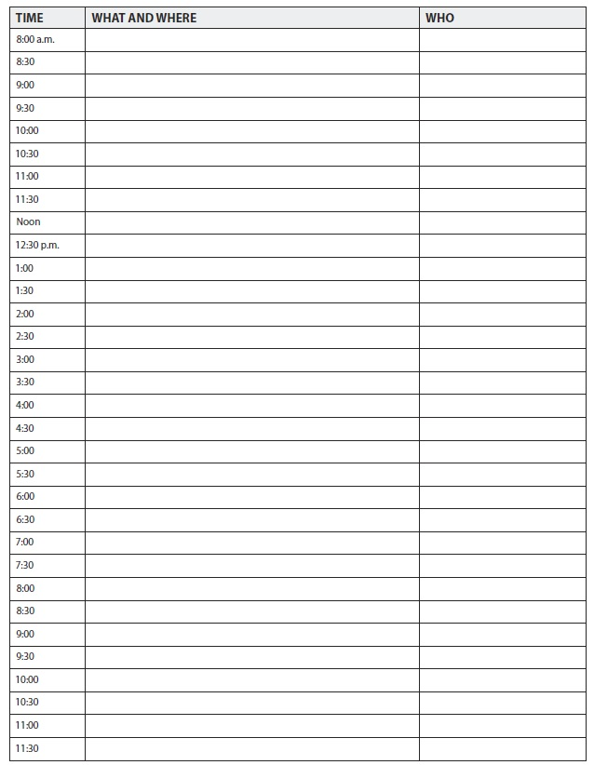

promotions

Overview: Promotions coordinator will coordinate the communication and promotions efforts related to this event in an effort to attract the targeted number of participants to the event.

Coordinator:

Contact info:

Information necessary to promote event:

What?

Who? _

Where?

When (date and time)?

Cost:

How?

Purpose:

Contact person for more information:

Special artwork: _

promotions

Ways in which event should be promoted (check all that apply):

- Email
- Church newsletter
- Student mailing
- Parent mailing
- Website (church)
- Facebook page and/or groups
- Phone calls to parents
- Announcements during Sunday school classes
- Announcements made by the senior pastor during worship service
- Announcements—other
- Newspaper ad (if so, which paper?) _________________
- Fliers for church
- Fliers for community (if so, designate where?)
- Other:_

Date promotions should begin

Date promotions should end

Specific dates for:

Deadline for ad in newspaper:

When mailings go out:

When information should be posted on the web:

When emails should be sent:

Deadline for information to go into church newsletter:

Phone calls should be made:

Announcements should be made:

Fliers should go up:

Date to follow up with Communications Coordinator:

promotions vendors

Were any vendors used for promotions? If so, include their contact information and the cost:

Graphic art vendor:

Contact info:

Service provided and cost:

Newspaper ad vendor:_

Contact info:

Service provided and cost:

Printing vendor:

Contact info:

Service provided and cost:

Other promotions vendor:

Contact info:

Service provided and cost:

Roster of participants

Name | Parent Contact Information

communications plan

How does a child or family sign up for this event?

Who is in charge of the roster?

Who is in charge of collecting fees (if applicable)?

Does a checklist or what-to-bring list need to be mailed to the children/families? Yes No

If so, who will create it?

Who will distribute it?

When does the checklist/to-bring list need to be distributed to the children or parents?

Do the children need a medical release form filled out for this event? Yes No

If so, who will:

get forms to children and parents?

make sure forms are collected?

What is the date that all forms should be collected?

Are there any other forms that need to be filled out for this event? Yes No

If so, list the forms below and the name of the person who will take care of distribution and collection of those forms.

Other:

food

Food coordinator:

Contact info:

What Specifics Who

- Snacks
- Meal
- Drinks
- Plates
- Napkins
- Cups
- Plasticware
- Bowls
- Other
How many people are being fed?
Time food is to be delivered:
Location of where food is to be delivered:
Who is setting up food?
Who is serving food?
Who is cleaning up food?
Who is going to write thank you notes to volunteers who provided/helped with food?

food

Thank you notes mailed (can be mailed from church) by:
Were any vendors used to provide food? If so, include their contact information and the cost:

Vendor:
Contact info:
Food provided and cost:
Other notes:

Off-campus event transportation

Location of event:

Time to arrive:

Length of stay:

Departure time:

Details of the activity:

Do reservations need to be made? Yes No

If so, who will make the reservations?

Deposit required? Yes No

If so, amount of deposit due by
Who will submit the check request?

Are other reservations necessary? Yes No

If so, list details below:

Carpool or transportation needed? Yes No

Were any vendors used to provide transportation? If so, include their contact information and cost:

Vendor:

Contact info:

Service provided and cost:

Off-campus event transportation

Permission slips for children/youth and for drivers of cars/van? Yes No

Who will take care of this?
Emergency phone number to be given to parents:

Where is the first-aid kit?

Who is responsible for the first-aid kit?

Other details listed below:

Meeting notes

Meeting date:

Participants:

Decisions made:

Action Item | Due Date | Responsible Party

Notes:

Additional documents

_____ Copies of promotional materials

_____ Copy of church’s tax-exempt form for volunteers to purchase needed supplies

_____ Copy of church’s reimbursement form and procedures needed to turn in receipts

_____ Copy of or link to the children’s ministry/youth ministry database

_____ Copy of church’s child-protection policy

_____ Instructions on what to do in case of an injury

_____ A map of the layout of the event

Post-event review

To be filled out and turned into the director of the children’s ministry/youth ministry (or interim staff) and a copy kept in this notebook.

Name and date of event:

Attendance:
_________ in childcare
_________ children
_________ family units
_________ teen helpers (if a children’s ministry event)
_________ youth participants (if a youth ministry event)
_________ adult volunteers

Were the goals or purpose of the event met? How?

What worked well?

What did not work well?

What would have been more helpful for the coordinator to know that will be helpful for the following coordinator to know?

What needs to be done differently next time?

Your name and contact information:

